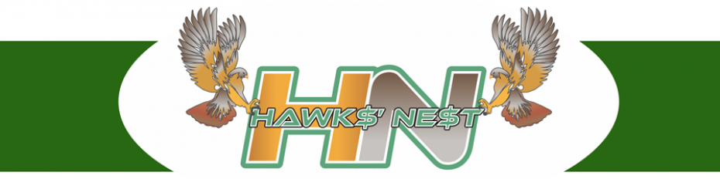
Hawks’ Nest FAQ’s

The following frequently asked questions are answered below:
- What is the Hawks’ Nest?
- What area does the Hawks’ Nest cover?
- Who can make a submission to the Hawks’ Nest?
- Do I have to attend a Business Plan Training session in order to make a submission?
- What is the submission deadline?
- How do I apply for the Hawks’ Nest?
- Will I have to make a presentation?
- How are the finalists chosen and how many?
- When will I know if I am a finalist?
- Who are the Hawks (investors)?
- How much money will be invested?
- Will the Hawks take part ownership of my business?
- Can I purchase tickets to the final event?
- Where do I find more information?

Question 1: What is the Hawks’ Nest?
Answer: The Hawks’ Nest is a “Dragons’ Den” inspired competition where entrepreneurs from various sectors will pitch their business ideas in an attempt to secure financial support from local angel investors coined the “Hawks.”

Question 2: What area does the Hawks’ Nest cover?
Answer: The Hawks’ Nest is presented by the Saugeen Economic Development Corporation (SEDC) and Bruce Community Futures Development Corporation (Bruce CFDC) and therefore cover the catchment areas of Grey and Bruce counties, Owen Sound, Minto and Wellington North.

Question 3: Who can make a submission to the Hawks’ Nest?
Answer: To be eligible - new, diversifying or expanding businesses must operate within the SEDC or the Bruce CFDC catchment areas as above and sign the Application Form accepting the terms and conditions outlined. Please note, franchises are not eligible to participate.

Question 4: Do I have to attend a Business Plan Training session in order to make a submission?
Answer: Applicants with a New business are required to take the business plan training. Expanding businesses are encouraged to do so and should present a plan in accordance with the template used for the training. The sessions are free and provide valuable information to assist with your submission.

Question 5: What is the submission deadline?
Answer: The Hawks’ Nest submission deadline is Friday, March 10th, 2023. All submissions must be received at SEDC or Bruce CFDC either in person, by courier, mail or email prior to 4:00 p.m. Email address for submissions hawksnest@sbdc.ca

Question 6: How do I apply for the Hawks’ Nest?
Answer: A maximum ten (10) page Business Plan must be submitted with a signed Application Form (available at www.sbdc.ca or www.bruce.on.ca) along with any additional documentation to support your proposal. All submissions must be received at SEDC or Bruce CFDC either in person, by courier, mail or email (hawksnest@sbdc.ca) prior to March 10th, 2023, by 4:00p.m.

Question 7: Will I have to make a presentation?
Answer: After submissions have been received, every applicant will be interviewed by SEDC and BCFDC representatives. Seven (7) finalists will then be selected to make a presentation (pitch) to the Hawks at the event on May 17th, 2023.

Question 8: How are the finalists chosen and how many?
Answer: All submissions including Business Plan supporting documentation will be reviewed as above. The reviewers will select seven (7) finalists to ‘pitch’ their Business Plan to the Hawks; one (1) finalist from the Youth Category, and six (6) finalists from the Open Category.

Question 9: When will I know if I am a finalist?
Answer: The reviewers will provide feedback to the project coordinator within a week of receiving the submissions. All applicants will be notified of the outcome and will be offered a meeting to discuss their proposals. Comments from the committee will be shared in assisting the entrepreneur in being successful.

Question 10: Who are the Hawks (investors)?
Answer: There are 6 Hawks (investors) whose names will be announced during the months of February, March and April 2023, and posted on the SEDC (www.sbdc.ca) and Bruce CFDC (www.bruce.on.ca) websites.

Question 11: How much money will be invested?
Answer: The six (6) Hawks (investors) have each committed to invest a minimum of $5,000 in a cash investment for the purpose of supporting at least one proposal at the event on May 17th, 2023. Therefore, a minimum $30,000 is up for grabs!

Question 12: Will the Hawks take part ownership of my business?
Answer: Much like the Dragon’s Den on television, the Hawks (investors) will be providing investment funds to the seven (7) finalists at their sole discretion… their money, their rules! Also keep in mind, the finalist has a choice to accept or not accept the Hawks offer.

Question 13: Where may I purchase tickets to the final event?
Answer: Call the Roxy Theatre at 519-371-2833 or email boxoffice@roxytheatre.ca or purchase online at: http://roxytheatre.ca/

Question 14: Where do I find more information?
Answer: Email hawksnest@sbdc.ca or contact Saugeen Economic Development Corporation (SEDC) and Bruce Community Futures Development Corporation (Bruce CFDC) at:
SEDC Bruce CFDC
www.sbdc.ca www.bruce.on.ca
1-888-832-2232 1-888-832-2232
hawksnest@sbdc.ca bfisher@bmts.com

